Parent Support Folder
Teacher: Mrs. Shirley & Ms. Smeyres
ESOL Teacher: Mrs. Law & Mrs. Blakeney
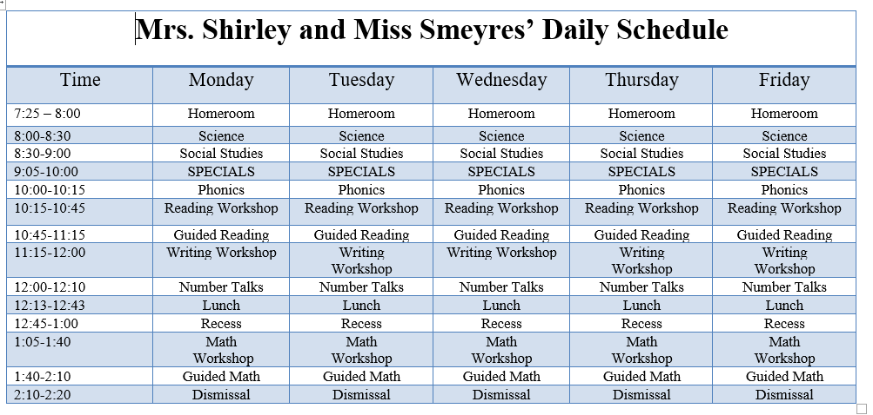
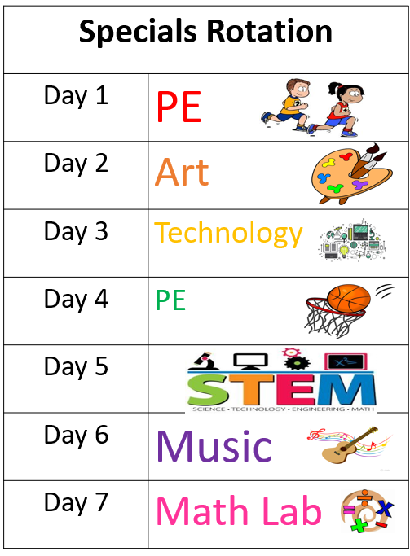
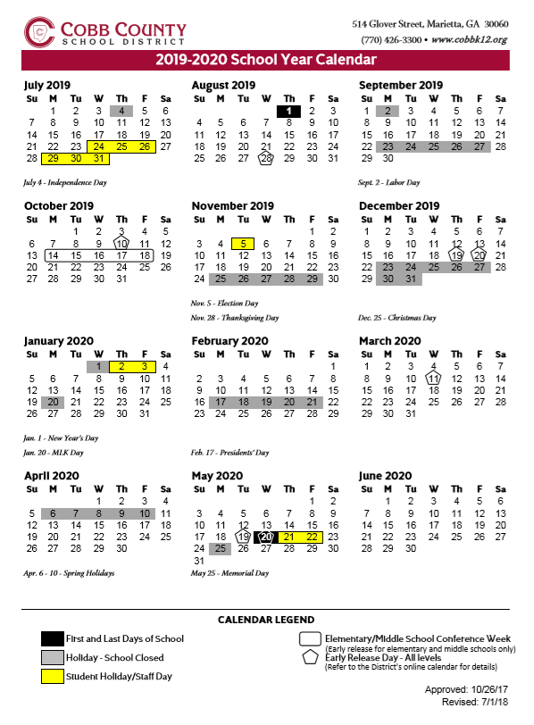
School Phone: 770.975.6600
Teacher Email: Heather.shirley@cobbk12.org Krystal.Smeyres@cobbk12.org Catherine.Law@cobbk12.org Amy. blakeney@cobbk12.org

